**

Ingeniería en Sistemas Computacionales

Fundamentos de Microprocesadores y Microcontroladores

Uso de memorias externas en el 89S52

727272 - Cordero Hernández Marco Ricardo

Zapopan, Jal., 06 de mayo del 2022

**Instrucciones**

Diseñe un sistema basado en el 89S52 que cumple con las siguientes especificaciones:

- Tiene 16Kb de memoria de código y 12Kb de memoria de datos.

- Cuenta con ROM de 4Kb únicamente (las que necesite).

- También posee memoria RAM de 4Kb (las que necesite).

- Las ROM deben localizarse a partir de la dirección 8000H.

- La memoria de datos inicia en la 4000H.

- Por necesidad especial del sistema, una RAM debe iniciar en 0000H.

Realice:

- Mapas de memoria del sistema.

- Decodificador de memorias del sistema (138 o compuertas lógicas).

- Realice el diagrama esquemático correspondiente.

**Mapas de memoria del sistema**

**Límites de ROM**

|  |  |  |  |  |  |  |  |  |  |  |  |  |  |  |  |  |  |  |  |  |  |
| --- | --- | --- | --- | --- | --- | --- | --- | --- | --- | --- | --- | --- | --- | --- | --- | --- | --- | --- | --- | --- | --- |
| A16 | A15 | A14 | A13 |  | A12 | A11 | A10 | A9 |  | A8 | A7 | A6 | A5 |  | A4 | A3 | A2 | A1 |  |  | |
| 32K | 16K | 8K | 4K | 2K | 1K | 512 | 256 | 128 | 64 | 32 | 16 | 8 | 4 | 2 | 1 |
| 0 | 0 | 0 | 0 | 0 | 0 | 0 | 0 | 0 | 0 | 0 | 0 | 0 | 0 | 0 | 0 | 0000H | Libre 1 |
| 0 | 1 | 1 | 1 | 1 | 1 | 1 | 1 | 1 | 1 | 1 | 1 | 1 | 1 | 1 | 1 | 7FFFH |
|  | | | |  | | | |  | | | |  | | | |  | |
| 1 | 0 | 0 | 0 | 0 | 0 | 0 | 0 | 0 | 0 | 0 | 0 | 0 | 0 | 0 | 0 | 8000H | ROM 1 |
| 1 | 0 | 0 | 0 | 1 | 1 | 1 | 1 | 1 | 1 | 1 | 1 | 1 | 1 | 1 | 1 | 8FFFH |
|  | | | |  | | | |  | | | |  | | | |  | |
| 1 | 0 | 0 | 1 | 0 | 0 | 0 | 0 | 0 | 0 | 0 | 0 | 0 | 0 | 0 | 0 | 9000H | ROM 2 |
| 1 | 0 | 0 | 1 | 1 | 1 | 1 | 1 | 1 | 1 | 1 | 1 | 1 | 1 | 1 | 1 | 9FFFH |
|  | | | |  | | | |  | | | |  | | | |  | |
| 1 | 0 | 1 | 0 | 0 | 0 | 0 | 0 | 0 | 0 | 0 | 0 | 0 | 0 | 0 | 0 | A000H | ROM 3 |
| 1 | 0 | 1 | 0 | 1 | 1 | 1 | 1 | 1 | 1 | 1 | 1 | 1 | 1 | 1 | 1 | AFFFH |
|  | | | |  | | | |  | | | |  | | | |  | |
| 1 | 0 | 1 | 1 | 0 | 0 | 0 | 0 | 0 | 0 | 0 | 0 | 0 | 0 | 0 | 0 | B000H | ROM 4 |
| 1 | 0 | 1 | 1 | 1 | 1 | 1 | 1 | 1 | 1 | 1 | 1 | 1 | 1 | 1 | 1 | BFFFH |
|  | | | |  | | | |  | | | |  | | | |  | |
| 1 | 1 | 0 | 0 | 0 | 0 | 0 | 0 | 0 | 0 | 0 | 0 | 0 | 0 | 0 | 0 | C000H | Libre 2 |
| 1 | 1 | 1 | 1 | 1 | 1 | 1 | 1 | 1 | 1 | 1 | 1 | 1 | 1 | 1 | 1 | FFFFH |

**Límites de RAM**

|  |  |  |  |  |  |  |  |  |  |  |  |  |  |  |  |  |  |  |  |  |  |
| --- | --- | --- | --- | --- | --- | --- | --- | --- | --- | --- | --- | --- | --- | --- | --- | --- | --- | --- | --- | --- | --- |
| A16 | A15 | A14 | A13 |  | A12 | A11 | A10 | A9 |  | A8 | A7 | A6 | A5 |  | A4 | A3 | A2 | A1 |  |  | |
| 32K | 16K | 8K | 4K | 2K | 1K | 512 | 256 | 128 | 64 | 32 | 16 | 8 | 4 | 2 | 1 |
| 0 | 0 | 0 | 0 | 0 | 0 | 0 | 0 | 0 | 0 | 0 | 0 | 0 | 0 | 0 | 0 | 0000H | RAM 1 |
| 0 | 0 | 0 | 0 | 1 | 1 | 1 | 1 | 1 | 1 | 1 | 1 | 1 | 1 | 1 | 1 | 0FFFH |
|  | | | |  | | | |  | | | |  | | | |  | |
| 0 | 0 | 0 | 1 | 0 | 0 | 0 | 0 | 0 | 0 | 0 | 0 | 0 | 0 | 0 | 0 | 1000H | Libre 1 |
| 0 | 0 | 1 | 1 | 1 | 1 | 1 | 1 | 1 | 1 | 1 | 1 | 1 | 1 | 1 | 1 | 3FFFH |
|  | | | |  | | | |  | | | |  | | | |  | |
| 0 | 1 | 0 | 0 | 0 | 0 | 0 | 0 | 0 | 0 | 0 | 0 | 0 | 0 | 0 | 0 | 4000H | RAM 2 |
| 0 | 1 | 0 | 0 | 1 | 1 | 1 | 1 | 1 | 1 | 1 | 1 | 1 | 1 | 1 | 1 | 4FFFH |
|  | | | |  | | | |  | | | |  | | | |  | |
| 0 | 1 | 0 | 1 | 0 | 0 | 0 | 0 | 0 | 0 | 0 | 0 | 0 | 0 | 0 | 0 | 5000H | RAM 3 |
| 0 | 1 | 0 | 1 | 1 | 1 | 1 | 1 | 1 | 1 | 1 | 1 | 1 | 1 | 1 | 1 | 5FFFH |
|  | | | |  | | | |  | | | |  | | | |  | |
| 0 | 1 | 1 | 0 | 0 | 0 | 0 | 0 | 0 | 0 | 0 | 0 | 0 | 0 | 0 | 0 | 6000H | Libre 2 |
| 1 | 1 | 1 | 1 | 1 | 1 | 1 | 1 | 1 | 1 | 1 | 1 | 1 | 1 | 1 | 1 | FFFFH |

**Decodificador(es) del sistema**

**Decodificador para ROM**

**Decodificador para RAM**

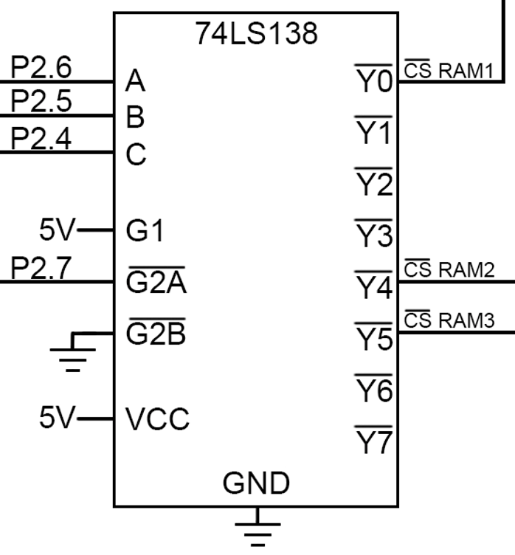

**Esquemático completo**